Laporan Praktikum 4



|  |
| --- |
| Disusun Untuk Memenuhi Tugas Mata Kuliah Web Programming 2 |
| Nama : Denis Oktaviano  NIM : 18090135  Kelas : 5C |

**PRODI D IV TEKNIK INFORMATIKA**

**POLITEKNIK HARAPAN BERSAMA TEGAL**

1. Source Code

v_footer.php -> application/views

v_header.php -> application/views

v_index.php -> application/views

v_about.php -> application/views

stylebuku.css -> assets/css

Web.php -> application/controllers

1. URL

<http://localhost/pustaka-booking-denis/web>

<http://localhost/pustaka-booking-denis/index.php/web/about>

1. Capture Output Program

* Home

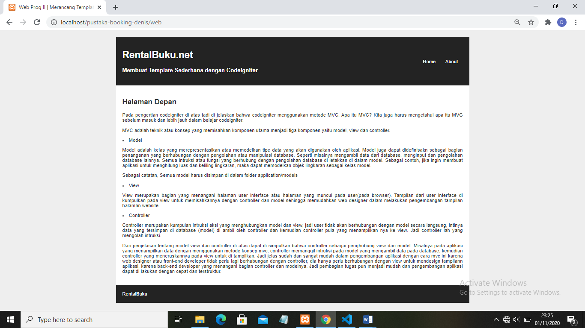

* About

